Step 1
open http://remix.ethereum.org
Step 2.
add plugins:
Compiler and Deploy and run Transaction
Step 3.
Add KYC.sol file to the files tructure
Step 4.
open compiler panel on left
change compiler version to 0.5.9
click on compile KYC.sol to compile the contract
Step 5.
Once the compilation is successful, i.e. you see a green tick on compiler icon,
open Deployment and Run Transaction panel on left

1.Select Environtment as JavaScriptVM
2.Select any one account value, REmix provides a default list of account addresses on blockchain
3. set GAS LIMIT to 300000000 or more
4. Select KYC.sol as the contract file

Under Deployed Contact, you see that the KYC contract is deployed.

Testing functions of KYC contract:

ADMIN Specific functions:

1. addBank():
PASS Test:
1.
- Copy one of the addresses(except the one that created the contract) from the list of ACCOUNTS and add it as bankAddres, name as you like; bankRegNum, any string value:

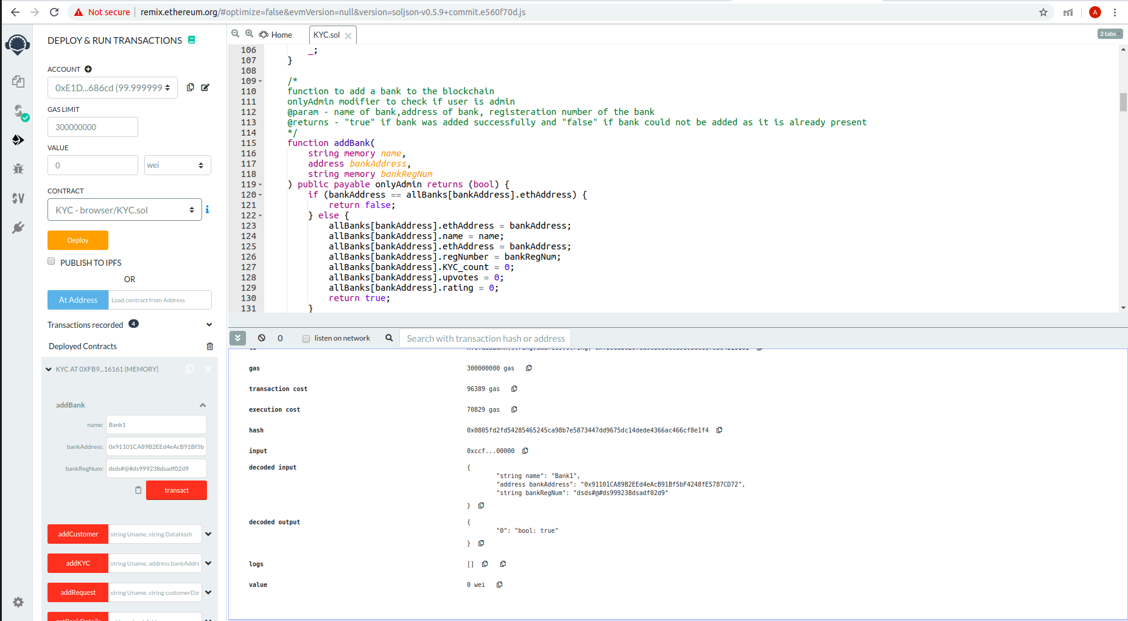

- You can check the console by expanding transaction info,
  - decoded output:
{ "0": "bool: true" )

Proves that bank is added
2.
- Add another bank with the same bankAddress as the previous one, the output is false, as Bank id already present in the list of banks.

FAILURE Test:
- Change sender address to Bank address(the one created in previous step)
and try to add another bank. An Error as below is returned:

transact to KYC.addBank errored: VM error: revert. revert The transaction has been reverted to the initial state. Reason provided by the contract: "Only admin can perform this action". Debug the transaction to get more information.

2. removeBank():
1. PASS Test:

1. Change ACCOUNT address to admin address and try to remove bank added previously:

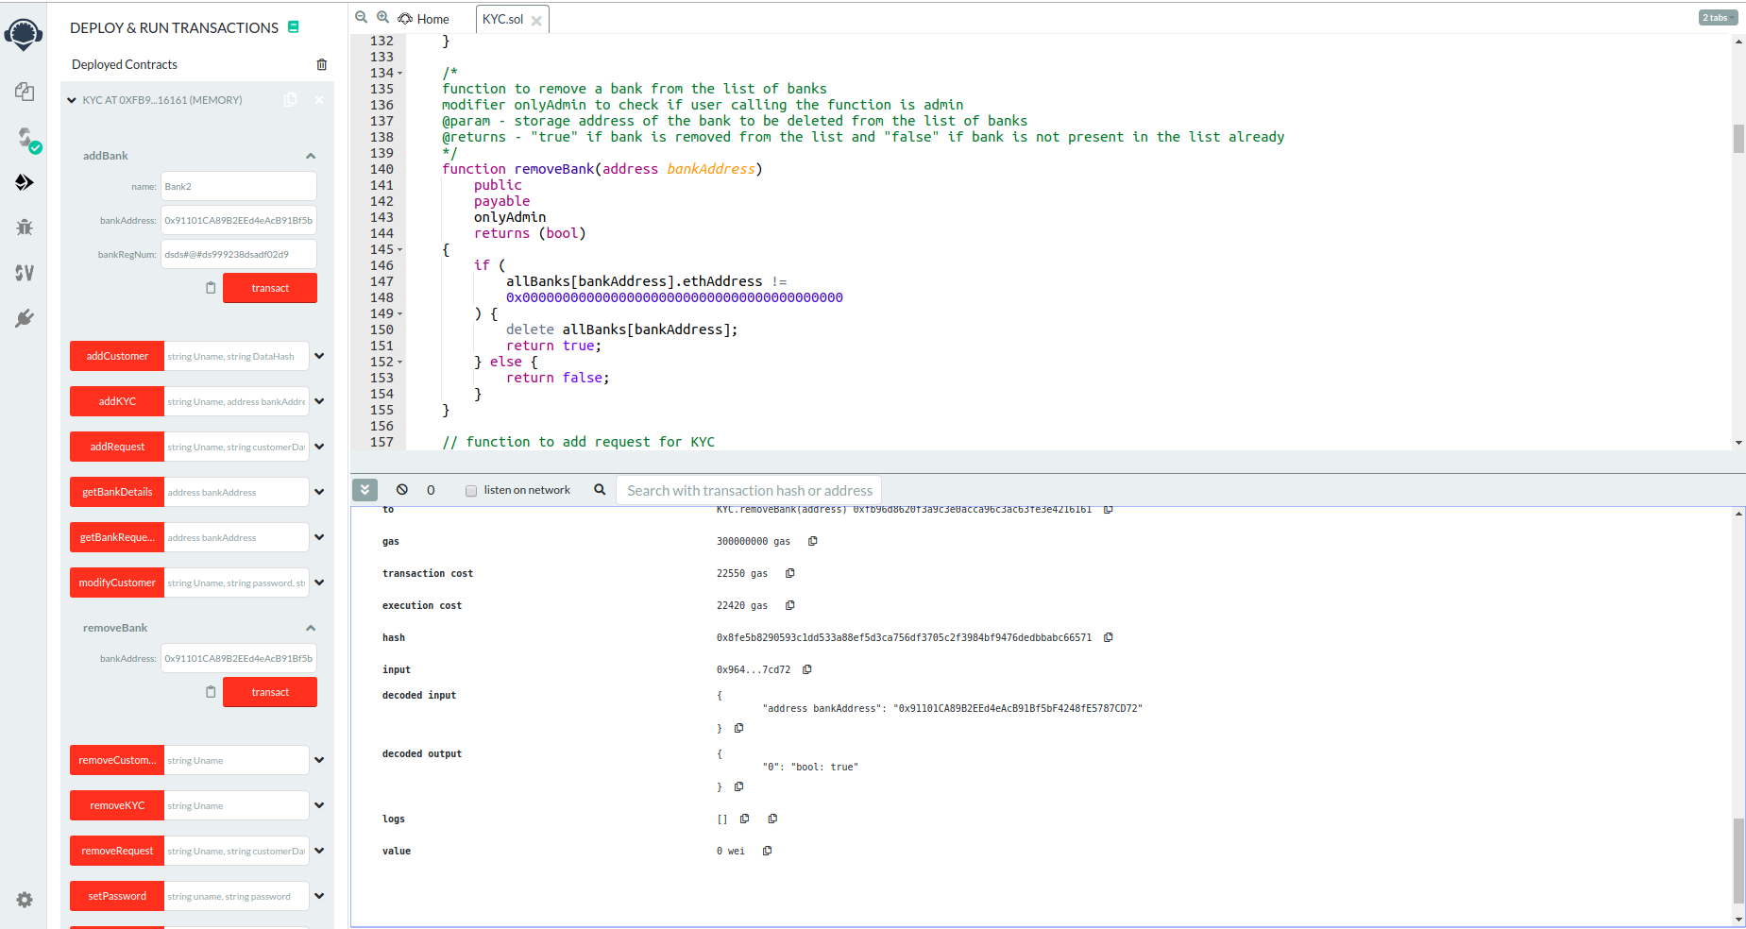
output is true indicating that bank has been removed from the list of banks

2. Try to remove a bank that is not present in the network:
pass invalid address as argument as admin, it should return false as output. Since the bank is not present in the list, it cannot be removed.

FAILURE Test:
Try to remove bank with sender address other than admin,
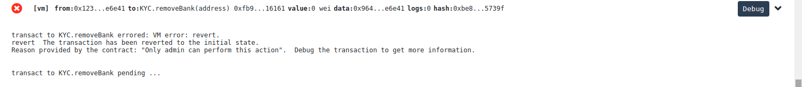
The above is returned.
BANK specific Functions:

In order to implement bank functions, add atleast 7 banks to the network.

1. upvoteBank()

This can be used to upvote a bank.
As soon as a bank is added,it has a rating of 0 and to add a customer to the network, the bank needs to have a rating of atleast 0.5

upvoteBank is used to upvote a bank sot that it is allowed to add a customer / upvote a customer for whom KYC request is pending.
Select any one of the bank and vote it so that its rating is more than 0.5(50 in this case).

2. addRequest()

This is used to add a request to add a customer’s KYC to the network. Once a request is added, a bank adds the customer to the network. Unless, the bank is not trusted(i.e. has rating more than 50), it cannot add a Request to the network.

If a request with the same username and datahash already exists in the list of requests, it cannot be added again.

3. addCustomer()

This can be used to add a customer to the network. It checks if the bank has already raised a request to add the customer and if thebank isAllowed(i.e. trusted) to add a customer to the network. If there conditions are met, customer data is added to the list and the customer’s rating and upvotes are set to 0. The default password for the customer is string “0”.
This password can be used to access the customer datahash in next step.

4.viewCustomer()

This is used by a bank to view customer datahash which can be verified by the bank. Once the bank verifies th datahash and is satisfied with the data provided, it can upvote the customer in next step.
Default password for any customer is “0”

5. upvoteCustomer()

Once a bank has viewed the data enteres by another bank, it can vote for customer data added using upvoteCustomer(). After adding the vote, it is checked if the customer rating is more than 50. If rating is more than 50, Customer data is added to final list of valid KYCs using 6. addKYC().
As long as the rating does not reach more than 50, the Customer details do not get added to the list of valid KYCs.

7.modifyCustomer()

Suppose if the bank is not satisfied with the customer data, it can modify the customer data. In this case, the customer KYC gets deleted from the list of valid KYCs by 8.removeKYC(). The customer needs to be upvoted again to add updated datahash to the list of valid KYCs.

The following functions are general functions that can be accessed by the bank to perform additional actions apart from requesting and updating KYCs.

9. removeCustomer()

It is used to remove customer from the list of customers. If the customer is present in the list, it is removed and 1 is returned as the output otherwise 0 is returned.

10. removeRequest()

It is used to remove a request from the list of requests raised to add a customer and add/update it KYC.

11. getBankDetails()

It is used to get the bank’s details on the basis of bank’s address. The details are returned as logs.

12. getBankRequest()

It accepts address of a bank as the argument and returns a list of requests raised by the bank in logs.

13. setPassword()

It is used to set password for a customer’s data. If the customer does not exist in the list of customers, it returns false, else it returns false.

